Advancing Aviation Safety Through Machine Learning and Psychophysiological Data

Abstract
In the aviation industry, safety remains vital, often compromised by pilot errors attributed to factors such as workload, fatigue, stress, and emotional disturbances. To address these challenges, recent research has increasingly leveraged psychophysiological data and machine learning techniques, offering the potential to enhance safety by understanding pilot behavior. This systematic literature review rigorously follows a widely accepted methodology, scrutinizing 80 peer-reviewed studies out of 3352 studies from five key electronic databases. The paper focuses on behavioral aspects, data types, preprocessing techniques, machine learning models, and performance metrics used in existing studies. It reveals that the majority of research disproportionately concentrates on workload and fatigue, leaving behavioral aspects like emotional responses and attention dynamics less explored. Machine learning models such as tree-based and support vector machines are most commonly employed, but the utilization of advanced techniques like deep learning remains limited. Traditional preprocessing techniques dominate the landscape, urging the need for advanced methods. Data imbalance and its impact on model performance is identified as a critical, underresearched area. The review uncovers significant methodological gaps, including the unexplored influence of preprocessing on model efficacy, lack of diversification in data collection environments, and limited focus on model explainability. The paper concludes by advocating for targeted future research to address these gaps, thereby promoting both methodological innovation and a more comprehensive understanding of pilot behavior.

Existing System
Aviation safety in the current system is heavily reliant on traditional monitoring techniques and post-event analysis to understand the behavior of pilots. While those techniques can identify specific operational errors, they often miss behaviorally based factors such as fatigue, stress, emotional disturbances, and workload spikes. Recent research is leveraging psychophysiological data and machine learning to predict pilot performance, although most studies are focused on a limited selection of measures. The majority of available studies are primarily related to workload and fatigue leaving often unexplored other critical behavioral influences such as emotional responses and attention dynamics. The continued reliance on paradigm shifting preprocessing techniques and individual machine learning model selection such as tree-based methods or support vector machines limits applications to reveal deeper behavioral patterns. Issues of data imbalance and lack of diverse environments reduce generalizability and accuracy. Lastly, studies rarely focus on explainability or interpretability in the models, which leads to issues implementing those systems across real-world aviation contexts.
Disadvantages
- No real-time continuous observation.
- No detection of subtle emotional or cognitive problems.
- No incorporation of physiological data and behavior modeling.
- Not adaptive to individual differences among pilots.

Proposed System
The suggested system tackles these gaps by providing a comprehensive framework encompassing reviews and improvements to machine learning approaches that analyze pilot behavior through psychophysiological data. The framework broadens the focus beyond workload and fatigue to other relevant behavioral aspects such as emotional state, stress level, and attention allocation. It advocates for more advanced preprocessing techniques to improve data quality while reducing noise and recommends more sophisticated and state-of-the-art machine learning and deep learning models for analyzing systems, enabling the capture of complex behavioral patterns. The system advocates for being cognizant of, and trying to alleviate, data imbalance to improve model performance and robustness. It supports the application of interpretive AI techniques to facilitate understanding and trust among aviation experts on the decisions made by the model. The proposed system will address the methodological gaps of data diversity, the impact of preprocessing, and model interpretability to develop a more accurate, robust, and transparent framework that understands pilot behavior, improves aviation safety.
Advantages
- Real-time and continuous monitoring of pilot behavior.
- Early warning of risk states enhances safety.
- Reduces human error by facilitating pilot decision-making.
- Assists in designing improved training and cockpit systems.

System Architecture
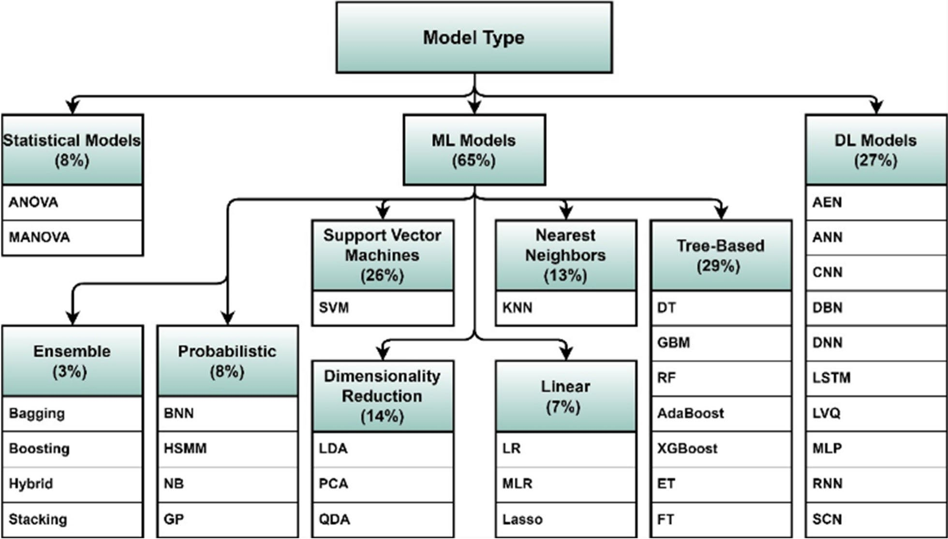

Module Description
1. Sensor Data Acquisition Module
Acquires EEG, ECG, eye-tracking, and other psychophysiological signals from pilots during flight or simulation.
2. Preprocessing & Feature Engineering Module
Preprocesses noisy data, eliminates artifacts, and extracts relevant features (such as brainwave bands, heart rate variability).
3. Machine Learning Modeling Module
Trains ML/DL models (SVM, decision trees, neural networks) to classify mental states such as fatigue, stress, and workload.
4. Real-Time Monitoring Module
Monitors pilots and predicts unsafe mental states in real time.
5. Feedback & Alert System Module
Alerts pilots and ground crew with alarms and visual dashboards when unsafe conditions are detected.

Hardware/Software Requirements
Hardware Requirements
- High-end CPU (i5+)
- 16GB RAM.
Software Requirements
- Python
- Scikit-learn
- TensorFlow
- MATLAB (optional).
Functional requirements
User Module (Pilots / Flight Operators)
- Secure Login – Pilot logs in to start monitoring session.
- Start Monitoring – Activate wearable sensors and begin flight/simulator monitoring.
- View Live Status – See real-time mental state (fatigue, stress, attention, workload) on dashboard.
- Receive Alerts – Get audio/visual warnings when unsafe conditions are detected.
- View Session Summary – Check post-flight performance and behavior analysis report.
- Download Report & Logout – Export session report and safely end the session.

Admin Module (Safety Analysts / System Engineers)
- Admin Login – Authorized administrator accesses system controls.
- User & Device Management – Add/remove pilots and configure EEG, ECG, and eye-tracking sensors.
- Data Processing Setup – Manage data storage, preprocessing, and feature extraction settings.
- Model Management – Train, update, and evaluate machine-learning models for mental state detection.
- Alert Configuration – Set thresholds for fatigue, stress, and attention risk alerts.
- Monitoring & Reports – Review system performance, generate safety analytics reports, and maintain backups.

